boxplot(mpg~cyl,data=mtcars,main="MPG VS CYL",xlab="CYL",ylab="MPG")

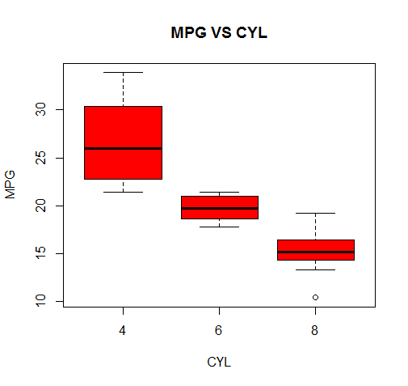

|  |
| --- |
| boxplot(mpg~am,data=mtcars,main="MPGVSAM",xlab="AM",ylab="MPG",col="red") |
|  |
| |  | | --- | | > | |